**MULTITHREADING ASSIGNMENT-2**

1) WAP to show usage of Callable and demonstrate how it is different from Runnable

OUTPUT-1

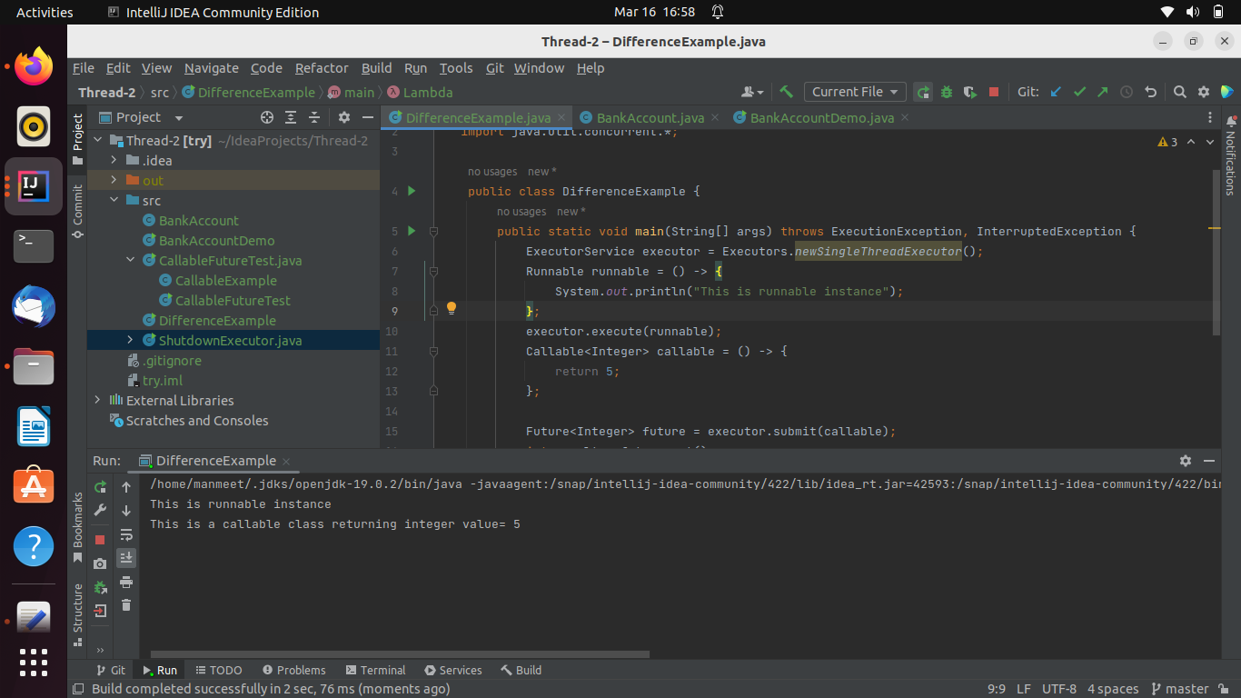

2) Improve the code written in Basics of Multi Threading Part 1 exercise question 4 to handle the deadlock using reentract lock.

OUTPUT-2

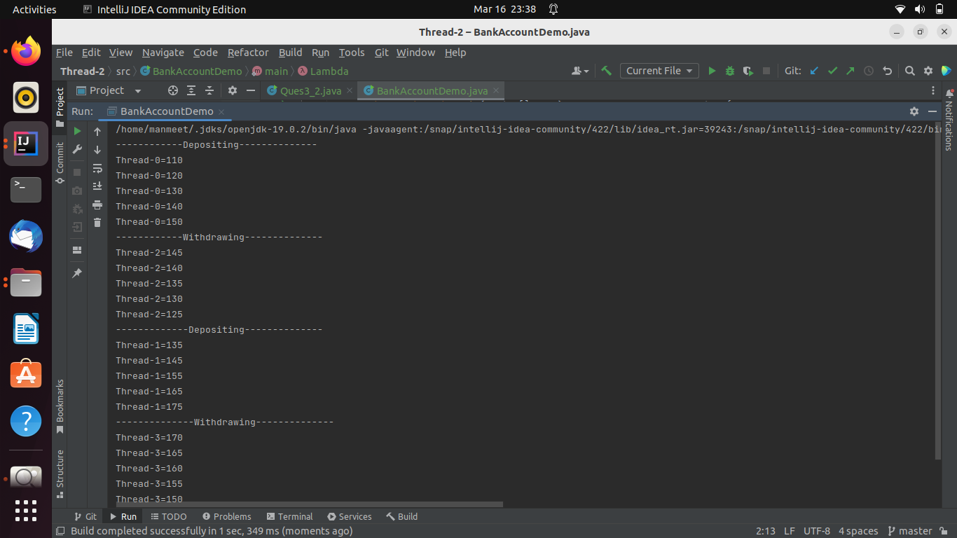

3) Use a singleThreadExecutor, newCachedThreadPool() and newFixedThreadPool() to submit a list of tasks and wait for completion of all tasks.

OUTPUT-3

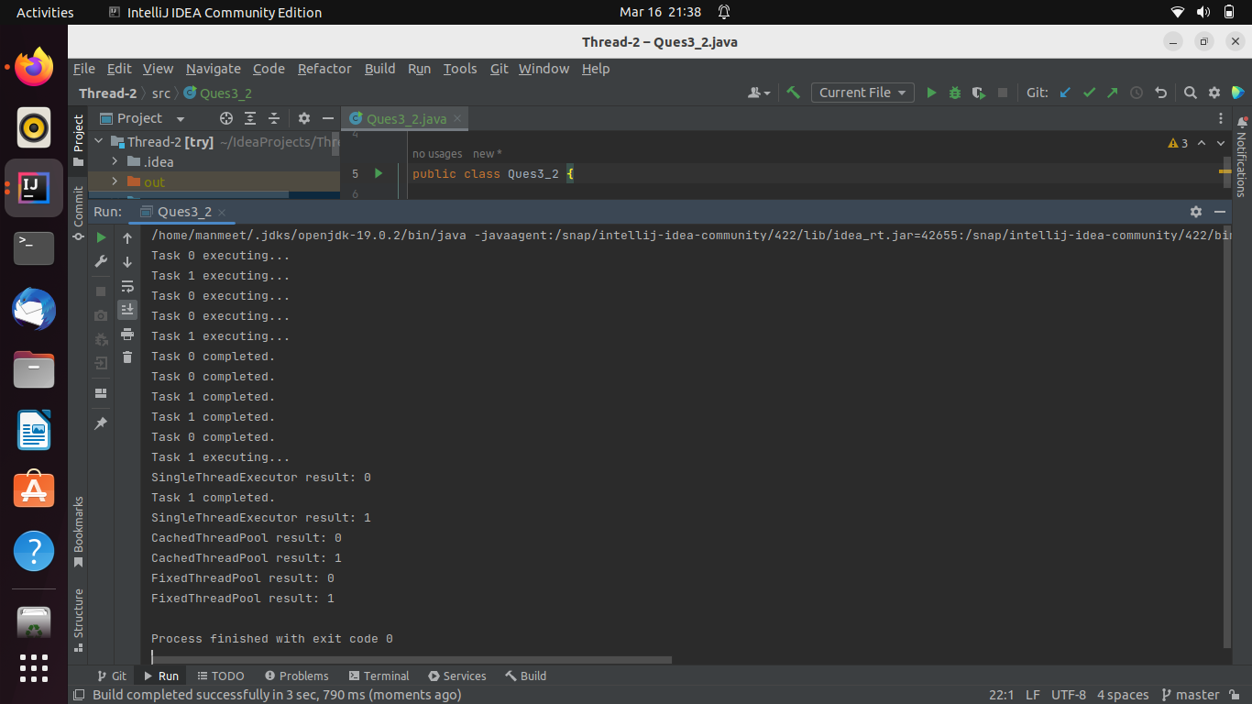

4) WAP to return a random integer value from a thread execution using Future.

OUTPUT-4

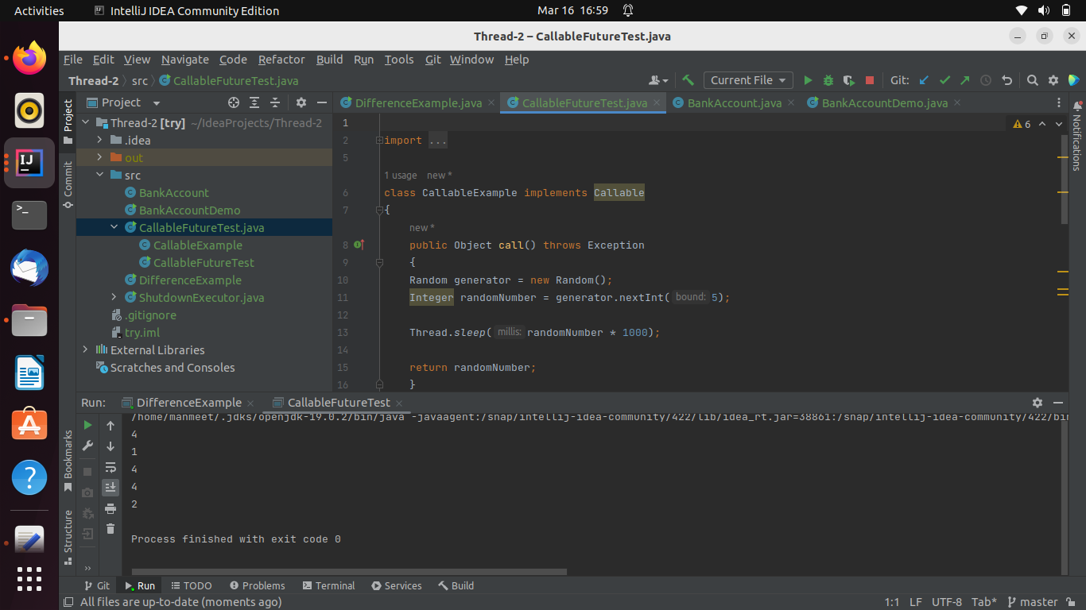

5) WAP to showcase the difference between shutdown() and shutdownNow().

OUTPUT-5

* FOR shutdownNow()

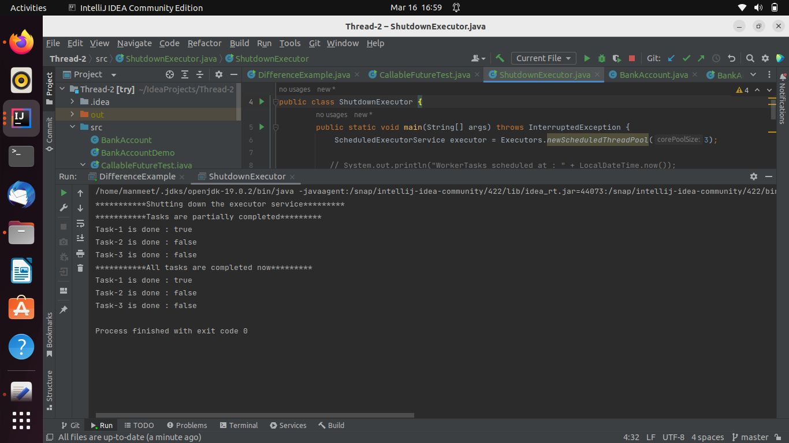

* For shutdown()

